**Steps for Setting Up a RAG ChatBot**

**Step 1: Create a Free Neo4j Instance**

1. Visit Neo4j Aura and sign up for a free account.
2. Set up a new Neo4j instance.
3. Once created, download and save the following credentials:
   * Neo4j connection URL
   * Username
   * Password
4. Once you have these credentials, proceed to **Step 2** to insert them into the code.

**Step 2: Create and Activate a Virtual Environment**

**Open PowerShell as Administrator**

1. Press **Win + S**, type **PowerShell**, and right-click **Run as Administrator**.

**Set Up the Virtual Environment**

1. Create a directory in the system with the name **"genai"**.



1. Navigate to the created directory.



1. Run the following command to create a virtual environment:



1. python -m venv venv
2. If you navigate to C:\Users\YourUsername\genai, inside venv, you'll find subfolders like Scripts, Lib, and Include.

**Activate the Virtual Environment**

1. Run the following command to activate the virtual environment:
2. .\venv\Scripts\activate



1. Once activated, you'll see **(venv)** appear before your command prompt.



**Install Required Python Packages**

Run each of the following commands inside the activated virtual environment:

python -m pip install langchain

python -m pip install langchain-community

python -m pip install langchain-openai

python -m pip install langchain-experimental

python -m pip install neo4j

python -m pip install tiktoken

python -m pip install yfiles_jupyter_graphs

python -m pip install streamlit

**Step 3: Download and Copy main.py & app.py into the Scripts Folder**

1. Download the provided main.py and app.py files from the given source.
2. Move these files inside the **Scripts** folder of your virtual environment.
3. Open main.py in a text editor (VS Code or Notepad).
4. Replace the placeholder API key and Neo4j credentials with your actual values.

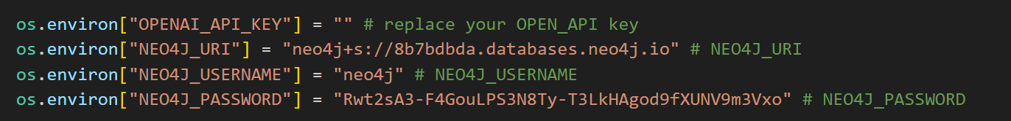

**Step 4: Go to the Google Colab Worksheet and Execute all the command consecutively.**

**Step 5: Run the Streamlit App**

Run the Streamlit application to launch the chatbot interface.

